聯合大學110年度第1學期 文創系課程連結
日文創一甲
課程 | 連結
商業攝影  (鍾雄秀) | https://teams.microsoft.com/l/team/19%3a-nBlEeSRDbojJi-S_jbcFym-4M0PajHoSkaNZZqYE3Q1%40thread.tacv2/conversations?groupId=21ad3cc9-a2e5-4779-a94e-2fbd9e31ed66&tenantId=245bbed3-de20-4af4-a01b-91bfcaa21e11
英文(一)  (王思涵) | 課程：英文(一) 文創一甲  開課課號：101DMA0002  平台：聯合數位學園 “課程討論”區 (進行非同步遠距教學)  http://elearning.nuu.edu.tw/mooc/index.php  (Teams 僅當師生該課程線上即時溝通使用，Tuesday 2-4 節。  連結： https://teams.microsoft.com/l/team/19%3a29U6X9WRIKzMU6mDvc4JFgkt1ecWyOh rhQEZla4pe201%40thread.tacv2/conversations?groupId=145c4a63-e5aa-4640-a00d4a1cfb7c836a&tenantId=245bbed3-de20-4af4-a01b-91bfcaa21e11)
社會學  (陳君山) | Teams代碼: dy865zg  連結:  https://teams.microsoft.com/l/team/19%3a_TinFsfGaN3GmEqHD5lIfcyDpdWaZjsJlhzSkucQvYE1%40thread.tacv2/conversations?groupId=31b64e40-ea9a-4d0c-9932-a695b1513c60&tenantId=245bbed3-de20-4af4-a01b-91bfcaa21e11
初級客語  (徐煥昇) | https://lin.ee/xIMzWIQ  初級客語 @ 連結
勞作教育  (施美淑) | 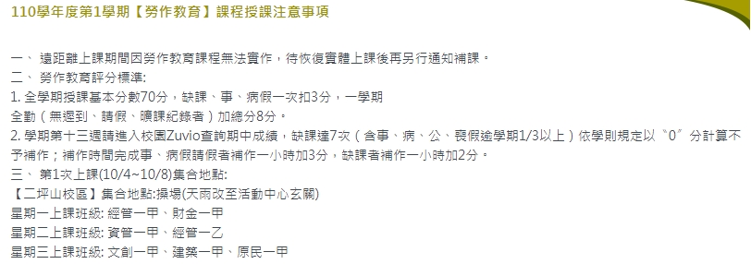
跨媒體軟體應用  (李筑軒) | Teams代碼: 4ymoyxx
大學導航  (李筑軒) | Teams代碼: 0h6398q
本國語文(一)  (賴欣陽) | https://teams.microsoft.com/l/channel/19%3aQWpwoqFqYyxYpV0_StN7g5VR22ltxQUYNntaIeCGx5k1%40thread.tacv2/%25E4%25B8%2580%25E8%2588%25AC?groupId=07d3c23f-49c2-46db-8a1c-61124201e91d&tenantId=245bbed3-de20-4af4-a01b-91bfcaa21e11  邀請碼：s74dop6
體育  -基礎游泳  (蔡俊傑) | Teams代碼:cootxhr  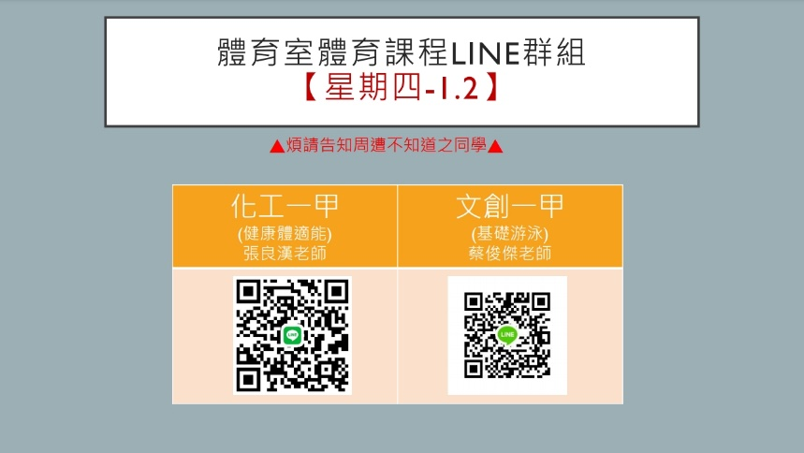 請參照附件: 110-1體育室體育課程Line群組
管理學  (胡愈寧) | Teams代碼: h1rn9qv
基礎設計(一)  (熊子扉) | https://teams.microsoft.com/l/team/19%3a-eKXL8hp3HZ-EeQaPQgAvzp6umCjocfVEDK_qEDX2jM1%40thread.tacv2/conversations?groupId=ec3bb579-cc0b-4965-ad8f-322b3654877a&tenantId=245bbed3-de20-4af4-a01b-91bfcaa21e11  Teams代碼: vsjh8v5  請掃描右列QR Code加入課程FB社團或FB搜尋聯大文創110學年度基礎設計(一)
電腦繪圖(一)  (熊子扉) | https://teams.microsoft.com/l/team/19%3aKZvS2kITMNkQp1NyB1EolqXmPUwwhlWVu8gneaurtSw1%40thread.tacv2/conversations?groupId=cdb3ce7a-f8b5-4348-a641-0f74d88bd7c2&tenantId=245bbed3-de20-4af4-a01b-91bfcaa21e11  Teams代碼: 85b3tmg  備註：請預先在家中電腦安裝軟體Adobe Photoshop喔～（課程使用ＣＣ版）  請掃描右列QR Code加入課程FB社團或FB搜尋聯大文創110級電腦繪圖
廣告文案與撰寫  (李威霆) | 廣告文案撰寫(日一甲)  https://teams.microsoft.com/l/channel/19%3acKoDuUm2GMUXf3fpofK2PKN5VH9VrtWOyoXY6YHdiBw1%40thread.tacv2/%25E4%25B8%2580%25E8%2588%25AC?groupId=35dfbe0f-cfe4-4490-9d92-49a49c8d8423&tenantId=245bbed3-de20-4af4-a01b-91bfcaa21e11
新文體撰寫  (徐仁清) | 課號/科目名稱：101DMA0018 新文體撰寫  上課時間：9月17日開課 星期五 10:10~11:00、11:10~12:00  授課老師：李威霆、徐仁清  線上網址：  Google Meet會議  https://meet.google.com/rzt-agid-fww  新文體撰寫(日一甲)  https://teams.microsoft.com/l/team/19%3auErIIQ9EC0N2BtOVAkWFoU89PEMtDAmMNWfRWsLxI1Q1%40thread.tacv2/conversations?groupId=68a8d5e0-5de1-4c60-996a-5f891e6125dd&tenantId=245bbed3-de20-4af4-a01b-91bfcaa21e11
素描與圖學  (楊德全) | http://line.me/ti/g/usbZbcIcCr
多媒體與網頁設計  (張陳基) | Teams代碼: romse3c  https://teams.microsoft.com/l/team/19%3abE4jRBomVtFBT9ZgJVOVhTlJX72QpFNEv_-9SbCv7UU1%40thread.tacv2/conversations?groupId=a32116ba-82bb-44b6-83b1-ff0084af1d6e&tenantId=245bbed3-de20-4af4-a01b-91bfcaa21e11

文創二甲
課程 | 連結
紀錄片製作 (鍾雄秀) | https://teams.microsoft.com/l/team/19%3agfV82g230IrkxOxwWzzFu76yNRwmoG6yD7uG-5EJsQE1%40thread.tacv2/conversations?groupId=32c56c92-7431-4d40-ac40-9c622a903427&tenantId=245bbed3-de20-4af4-a01b-91bfcaa21e11
研究方法與統計  (陳君山) | 線上課程以Microsoft Teams進行，課程連結為https://teams.microsoft.com/l/team/19%3anSDUNkQ9rjE17T1LpxGwWXJM783gmRKBECMeFV7Ivoc1%40thread.tacv2/conversations?groupId=eac577fa-08f3-4785-a29e-3e2d87db892d&tenantId=245bbed3-de20-4af4-a01b-91bfcaa21e11
包裝與結構設計  (熊子扉) | https://teams.microsoft.com/l/team/19%3a0lSKBZoE3TQ4WTmJIL5u7-EyraO1PyhXcS4oo99ACvM1%40thread.tacv2/conversations?groupId=d8f8dbd0-5749-4763-a6db-4ff609ab90cf&tenantId=245bbed3-de20-4af4-a01b-91bfcaa21e11  Teams代碼: f60ft42  請掃描右列QR Code加入課程FB社團或FB搜尋聯大文創110學年度包裝與結構設計
民主與法治(周德榮) | Teams代碼: cepcjka
3D列印  (李筑軒) | Teams代碼: jd49hyj
閱聽人分析  (盧嵐蘭) | Teams團隊代碼：e3qidzn  團隊連結：https://reurl.cc/2rpKYv
設計表現技法  (黃筱茜) | https://teams.microsoft.com/l/channel/19%3a7liYPC65ztxnJWd9SHh7AZEN_DCMGfq_msE_5P6KZjM1%40thread.tacv2/%25E4%25B8%2580%25E8%2588%25AC?groupId=f833bbf6-a2da-4fe2-941e-3a70bf5caede&tenantId=16ee8c6d-0af0-4c52-876d-cdfaed578bce
文化產業管理(胡愈寧) | Teams代碼: l6xxicj
體育(三)  (吳貴琍) | 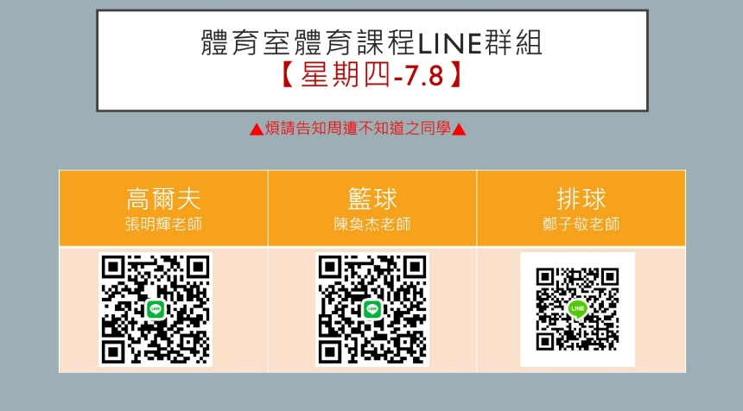  請參照附件: 110-1體育室體育課程Line群組
色彩學  (熊子扉) | https://teams.microsoft.com/l/team/19%3aHpQCGvR4PEn9gOfbPqx2t3sV-uL3kordGQjLwWQMWdU1%40thread.tacv2/conversations?groupId=133719bc-13f6-4718-8cd9-acef6e47efd5&tenantId=245bbed3-de20-4af4-a01b-91bfcaa21e11  Teams代碼: xny9drw  請掃描右列QR Code加入課程FB社團或FB搜尋聯合文創110年度色彩學
客家歷史與文化  (張正霖) | Teams代碼: h79tdx7

文創三甲
課程 | 連結
企業概論  (周志隆) | https://meet.google.com/ffh-eais-eut
消費者行為  (胡愈寧) | Teams代碼: oad47n9
文創商品開發實務(一)  (熊子扉) | https://teams.microsoft.com/l/team/19%3aqEFdgx2aor_JAqphh8dntdBdVw0JR5iwQDtBF9U1z341%40thread.tacv2/conversations?groupId=4eaa653a-8db7-462c-8cf1-721b4f04b50c&tenantId=245bbed3-de20-4af4-a01b-91bfcaa21e11  Teams代碼: rdhux38  請掃描右列QR Code加入課程FB社團或FB搜尋聯合文創110年度文創商品開發實務(一)
藝術概論  (張正霖) | Teams代碼:iirri62
文化行政與政策  (張正霖) | Teams代碼:wg70ik4
品牌經營與管理(李筑軒) | Teams代碼: robvbza
業務行銷實務
(施櫂遠)
社區與空間營造  (林志銘) | 日文創三甲 社區空間設計：https://teams.microsoft.com/l/channel/19%3aEzcQN6O4AkE-gNUJIm7xIQSZtyILOXyMxTdf5D9fCKQ1%40thread.tacv2/%25E4%25B8%2580%25E8%2588%25AC?groupId=fa76e8c4-9999-4fb3-a9fb-8fb30c70a74f&tenantId=245bbed3-de20-4af4-a01b-91bfcaa21e11
數位與文創  (徐仁清) | 課號/科目名稱：101DMA0091 數位與文創  上課時間：9月17日開課 星期五 13:00~13:50、14:00~14:50  授課老師：徐仁清  線上網址：  Google Meet會議  https://meet.google.com/fec-epzr-zoh

文創四甲
課程 | 連結
AR/VR專題  (陳君山) | 線上課程以Microsoft Teams進行，課程連結  為https://teams.microsoft.com/l/team/19%3aRfqqJb9YZupbiR4AONH8QBYGbfIUx2  5jd3UmOat8bPk1%40thread.tacv2/conversations?groupId=e27d79c2-c52c-4678-8  2ce-13c003368d3e&tenantId=245bbed3-de20-4af4-a01b-91bfcaa21e11
智慧財產權  (李威霆) | 智慧財產與職場倫理(日間四甲)  https://teams.microsoft.com/l/channel/19%3a4e2f3f7a7f3344f3bdf782b001844c45%40thread.tacv2/107%25E6%2597%25A5%25E9%2596%2593?groupId=57669de1-142c-4aee-91f7-38f0196a735e&tenantId=245bbed3-de20-4af4-a01b-91bfcaa21e11
社會設計(一)  (林志銘) | 日文創四甲 社會設計 https://teams.microsoft.com/l/channel/19%3amC9uek8d2dSTN02hDetLT26dxJZYlpXB3VWT-ciVlUI1%40thread.tacv2/%25E4%25B8%2580%25E8%2588%25AC?groupId=53ff764b-67cb-48d4-a7b7-765a4ab940d9&tenantId=245bbed3-de20-4af4-a01b-91bfcaa21e11
行動平台遊戲開發實務  (徐仁清) | 課號/科目名稱：101DMA0055 行動平台遊戲開發實務  上課時間：9月17日開課 星期五 15:10~16:00、16:10~17:00  授課老師：徐仁清  線上網址：  Google Meet會議  https://meet.google.com/nwn-omok-qxp

夜文創一甲
課程 | 連結
社會學  (陳君山) | Teams代碼: u07262c  連結:  https://teams.microsoft.com/l/team/19%3a2jIIAqoe_48FQzVYUsNeNhrLw0YC-bwhcIMNHGU8dl81%40thread.tacv2/conversations?groupId=b2bbf1ab-906f-4c0f-93a1-52b5d9f1e42b&tenantId=245bbed3-de20-4af4-a01b-91bfcaa21e11
管理學  (胡愈寧) | Teams代碼: ozlwm3j
跨媒體軟體應用  (李筑軒) | Teams代碼: 5mev0q2
本國語文(一)  (賴欣陽) | 邀請碼：seda4t8  https://teams.microsoft.com/l/team/19%3ayCWB7bQ6hR_D4dOD5p5GwaELSJGQmYkTgqiRv6BN0hU1%40thread.tacv2/conversations?groupId=521cb550-9c37-435a-9fdf-f4ed3acc4a99&tenantId=245bbed3-de20-4af4-a01b-91bfcaa21e11
商業攝影  (葉羽曼) | 商業攝影 夜文創一甲  https://meet.google.com/xkb-cuqm-xgi
電腦軟體應用(羅紹竹) | 會議室編號: 1585702354  https://meet89.webex.com/meet/pr1585702354
體育  -基礎游泳  (蔡俊傑) | 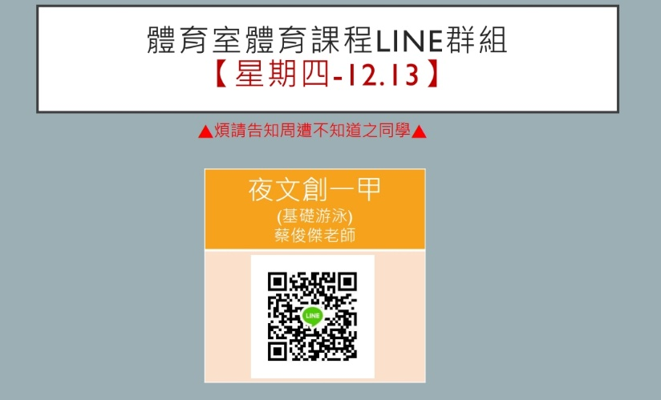  請參照附件: 110-1體育室體育課程Line群組
基礎設計  (林育全) | Teams代碼: wth4632  連結:  https://teams.microsoft.com/l/team/19%3aW3hy5EtOlOPToCP13Uoes9ngg4fL-SKFNThMs3lWD701%40thread.tacv2/conversations?groupId=bd66e671-24c4-4d36-af9b-30a5be456267&tenantId=245bbed3-de20-4af4-a01b-91bfcaa21e11
電腦繪圖  (羅紹竹) | 會議室編號: 1585702354  https://meet89.webex.com/meet/pr1585702354
英文(一)  (張民光) | 課程：夜文創一甲大一英文  開課課號：101DMA0003  平台：https://elearning.nuu.edu.tw/learn/index.php  連結： 聯合數位學園 (nuu.edu.tw) 本校 Mail 帳號登入  代碼： mkchang / 903435 / 我的課程
廣告文案設計(朱國志) | Google會議代碼: hym-sbis-rjh  連結: https://meet.google.com/hym-sbis-rjh

夜文創二甲
課程 | 連結
體育(三)  (何忠鋒) | 請參照附件: 110-1體育室體育課程Line群組
統計學  (周志隆) | https://meet.google.com/ffh-eais-eut
藝術概論  (張正霖) | 課程代碼: 5xg1g2e
客家歷史與文化  (張正霖) | 課程代碼: kz2e7wd
數位影視製作 | 數位影視製作(進修二甲)  https://teams.microsoft.com/l/channel/19%3afd17dfba5e0247808e6178b6ce5301bb%40thread.tacv2/109%25E9%2580%25B2%25E4%25BF%25AE%25E4%25BA%258C%25E7%2594%25B2?groupId=61eb29e0-06ea-4b95-80a2-0c2e9abb9bb1&tenantId=245bbed3-de20-4af4-a01b-91bfcaa21e11
經濟學  (李威霆) | 經濟學(進修二甲)  https://teams.microsoft.com/l/channel/19%3a2ed1602704394adaae4a46254b605649%40thread.tacv2/109%25E9%2580%25B2%25E4%25BF%25AE%25E4%25BA%258C%25E7%2594%25B2?groupId=28fdb8df-e48a-4add-9d3a-9210e16fc516&tenantId=245bbed3-de20-4af4-a01b-91bfcaa21e11
文化產業管理
(施櫂遠)
多媒體與網頁設計  (張陳基) | TEAMS遠距教學連結50a1i9b  https://teams.microsoft.com/l/team/19%3aKGn6VZew15h7Gx2bWMB-GQB_Kte0VnNicz5Zm_1yaRk1%40thread.tacv2/conversations?groupId=021291f3-f2b4-46bc-951e-8c7916853631&tenantId=245bbed3-de20-4af4-a01b-91bfcaa21e11
體驗行銷  (蘇瑞蓮) | https://teams.microsoft.com/l/team/19%3agMrMiZQ5MCVRSKUbR7YDBoEQBs0nWkr0liA4GTuQfAE1%40thread.tacv2/conversations?groupId=196f800e-a221-4153-a1ed-df98029ffdec&tenantId=245bbed3-de20-4af4-a01b-91bfcaa21e11
中級客語  (陳美蓉) | https://teams.microsoft.com/l/team/19%3aTSLv2y0HNGwNNc6qNsXOS2kT3hUV-7acEf63cNN-yAQ1%40thread.tacv2/conversations?groupId=f378de5f-d1f8-44d2-9747-b19a89b2cc18&tenantId=245bbed3-de20-4af4-a01b-91bfcaa21e11

夜文創三甲
課程 | 連結
消費者行為  (周志隆) | https://meet.google.com/ffh-eais-eut
文化行政與政策  (陳君山) | 文化行政與政策連結 夜文創三甲  https://meet.google.com/hge-okjm-hhk
實務專題(一)  (胡愈寧) | https://teams.microsoft.com/l/team/19%3aqRMpGsRcImpev-2IV33rLvjTRHNDyTI37rJFFP37rNg1%40thread.tacv2/conversations?groupId=0b7fc938-2391-42e3-82c5-02543bde0d9e&tenantId=245bbed3-de20-4af4-a01b-91bfcaa21e11
品牌設計  (黃筱茜) | https://teams.microsoft.com/l/channel/19%3a4AjevAVAm3zHONr5uNiSt_D0UryqAhi-pO8MsnZQpgs1%40thread.tacv2/%25E4%25B8%2580%25E8%2588%25AC?groupId=6cf17749-0710-40a2-a9bc-ecde4043a997&tenantId=16ee8c6d-0af0-4c52-876d-cdfaed578bce
客家政策與產業  (任文瑗) | 客家政策與產業 TEAMS連結: 33wy23g
3D設計與列印  (李筑軒) | Teams代碼: 0605ulf
文化治理  (林奕辰) | Teams代碼: 19frpek  連結: https://teams.microsoft.com/l/channel/19%3a56vNsuy73hRpYaY-KC7CtExOOLlt2tYzeruEr0AzBdA1%40thread.tacv2/%25E4%25B8%2580%25E8%2588%25AC?groupId=e2a8ddef-5245-420c-8969-8d0597e701da&tenantId=245bbed3-de20-4af4-a01b-91bfcaa21e11
應用客語  (陳美蓉) | https://teams.microsoft.com/l/channel/19%3a0jZf8-V9Hw3d0m0FZqOTl7WEiI45fHcZCgtVtlPkQEw1%40thread.tacv2/%25E4%25B8%2580%25E8%2588%25AC?groupId=acf046b6-1736-43be-a910-9f22e5cc789a&tenantId=245bbed3-de20-4af4-a01b-91bfcaa21e11
文化產業與行銷  (朱國志) | Google會議代碼: adu-vhxy-msm  連結: https://meet.google.com/adu-vhxy-msm

夜文創四甲
課程 | 連結
智慧財產權與職場倫理  (李威霆) | 智慧財產與職場倫理(107進修四甲)  https://teams.microsoft.com/l/channel/19%3a5a00bf025691415db57a4a10a8cad741%40thread.tacv2/107%25E9%2580%25B2%25E4%25BF%25AE?groupId=57669de1-142c-4aee-91f7-38f0196a735e&tenantId=245bbed3-de20-4af4-a01b-91bfcaa21e11
創意城市  (林奕辰) | Teams代碼: 4rw6lcm  連結:  https://teams.microsoft.com/l/channel/19%3aifoRjGG2h99QCLD1u4xekPYJbjIRWXjZ1ZH3CERXYbw1%40thread.tacv2/%25E4%25B8%2580%25E8%2588%25AC?groupId=dae9cc5c-d44b-49f6-b5bd-a3abf068827f&tenantId=245bbed3-de20-4af4-a01b-91bfcaa21e11
創新設計  (林育全) | Teams代碼: c65p6ca  連結:  https://teams.microsoft.com/l/team/19%3a7MkpNu4zSSJYIfm3Wvrd2xjpSeUb9m8tzkmPBA9Md2g1%40thread.tacv2/conversations?groupId=287250b7-ad0c-47aa-a391-eb972403fb1c&tenantId=245bbed3-de20-4af4-a01b-91bfcaa21e11

